- Write a Python program to generate a complete summary of an employee dataset showing:
- Number of rows
- Number of columns
- Data types
- Missing values
- Statistical summary
- Write a Python program to calculate the frequency distribution of students' grades and display the results using a bar chart.
- Write a Python program to plot the histogram of house prices and identify whether the data is normally distributed or skewed.
- Write a Python program to create a box plot of salary data and identify the presence of outliers.
- Write a Python program to detect outliers in students' marks using the Interquartile Range (IQR) method.
- Write a Python program to remove outliers from a sales dataset using the IQR method and display the cleaned dataset.
- Write a Python program to plot histograms and box plots before and after removing outliers from a dataset.
- Download the Iris or Titanic dataset and perform Exploratory Data Analysis by:
- Displaying dataset information
- Finding missing values
- Computing descriptive statistics
- Plotting histograms
- Plotting box plots
- Detecting outliers
- Removing outliers
- Saving the cleaned dataset

Experiment 1 .Employee Dataset Summary using Python
Aim
To read an employee dataset and display the number of rows, columns, data types, missing values, and statistical summary using Pandas.
Algorithm
- Import the Pandas library.
- Read the employee dataset using read_csv().
- Display the number of rows and columns.
- Display the data types of all columns.
- Find missing values using isnull().sum().
- Display statistical summary using describe().
- End the program.

CODE:

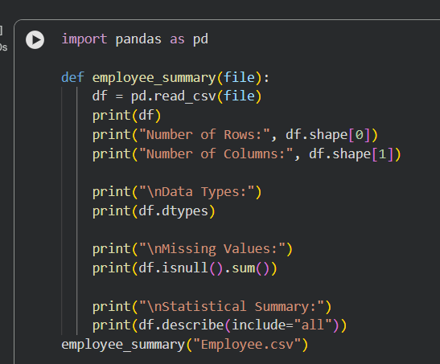

OUTPUT:
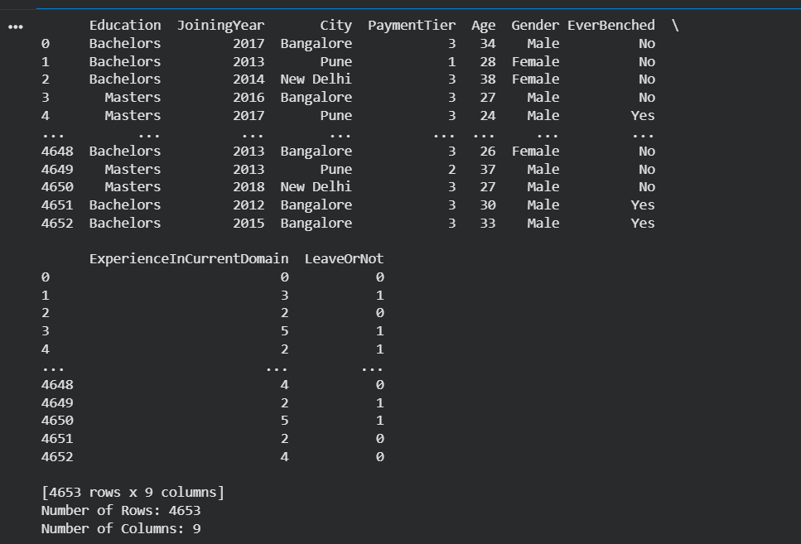
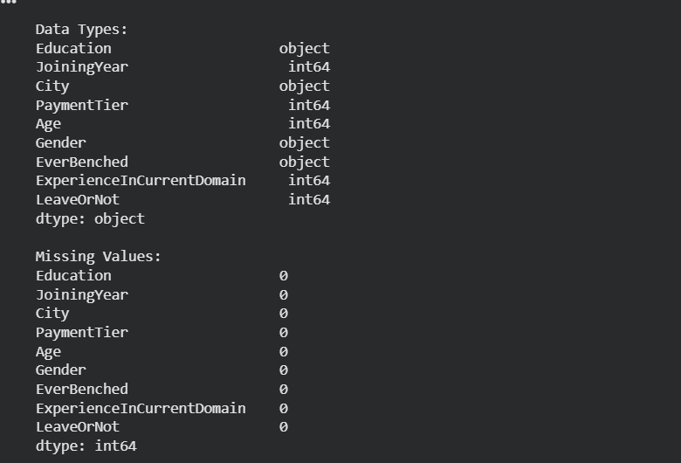

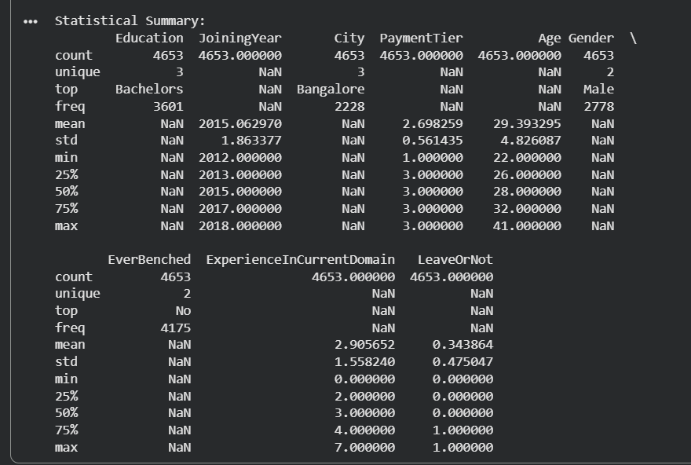

Experiment 2: Frequency Distribution of Students' Grades
Aim
To calculate the frequency of students' grades and visualize it using a bar chart.
Algorithm
- Import Pandas and Matplotlib.
- Read the grades dataset.
- Count the frequency of each grade using value_counts().
- Display the frequency table.
- Plot a bar chart.
- Add title and axis labels.
- Display the chart.

CODE:
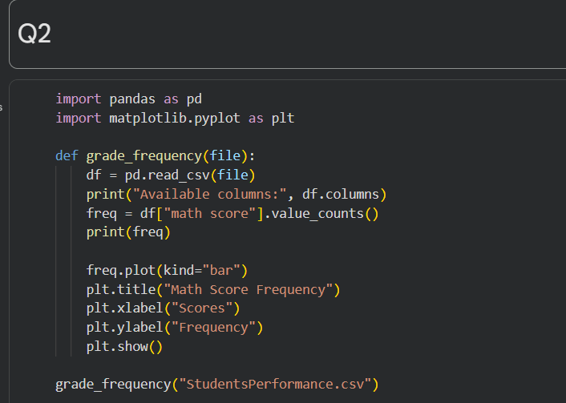
OUTPUT:
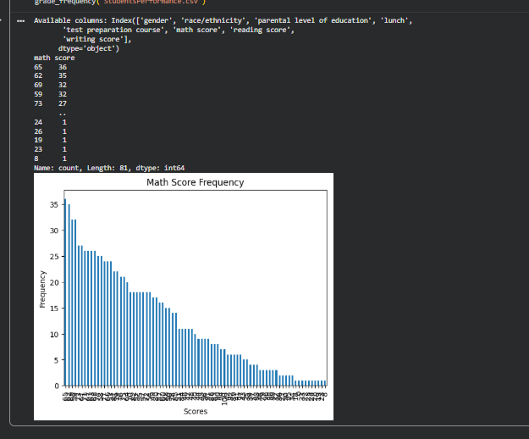
Experiment 3: Histogram of House Prices
Aim
To plot a histogram of house prices and identify whether the data is normally distributed or skewed.
Algorithm
- Import Pandas and Matplotlib.
- Read the house price dataset.
- Select the price column.
- Plot a histogram using plt.hist().
- Add title and axis labels.
- Display the histogram.
- Observe the distribution.
CODE:
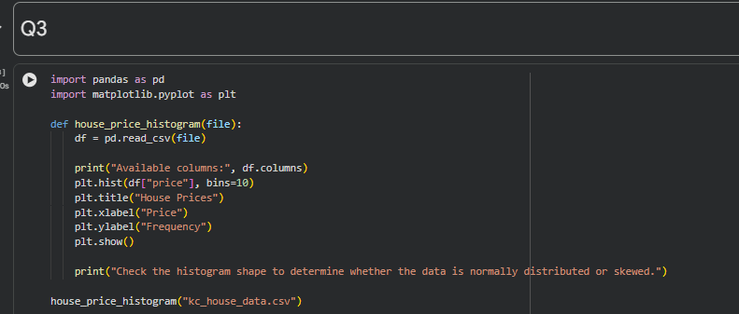

OUTPUT:
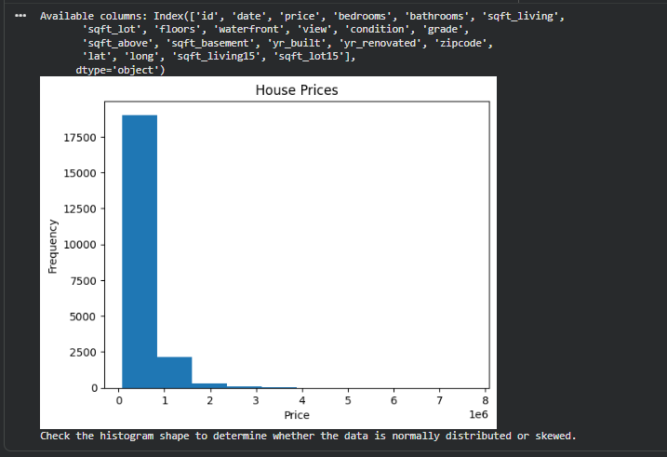
Experiment 4: Box Plot of Salary Data
Title
Box Plot of Salary Data
Aim
To create a box plot for salary data and identify the presence of outliers.
Algorithm
- Import Pandas and Matplotlib.
- Read the salary dataset.
- Select the salary column.
- Plot a box plot using plt.boxplot().
- Add title and labels.
- Display the plot.
- Identify outliers outside the whiskers.
CODE:
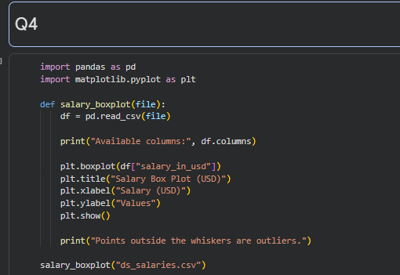
OUTPUT:
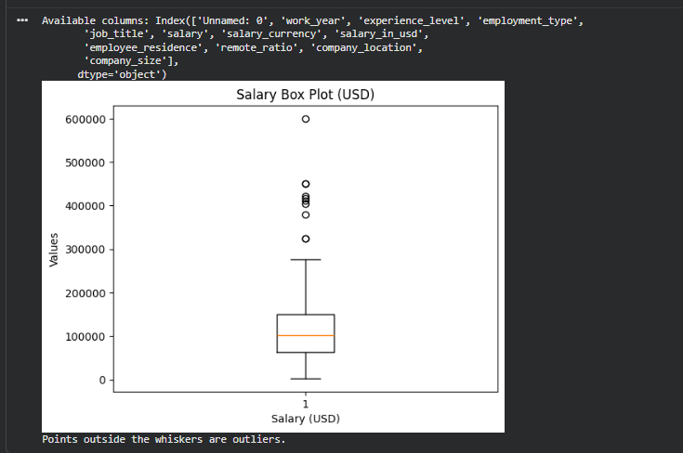

Experiment 5: Detect Outliers using IQR
Title
Outlier Detection using Interquartile Range (IQR)
Aim
To detect outliers in students' marks using the Interquartile Range (IQR) method.
Algorithm
- Import Pandas.
- Read the students' marks dataset.
- Calculate Q1 and Q3.
- Calculate IQR = Q3 − Q1.
- Find lower and upper limits.
- Detect values outside these limits.
- Display the outliers.

CODE:
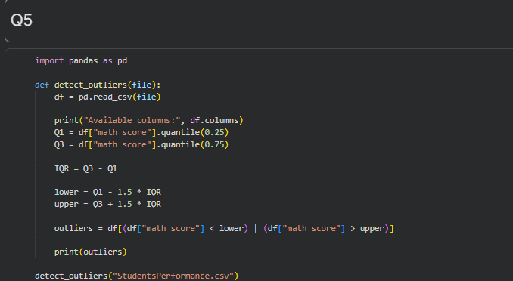
OUTPUT:
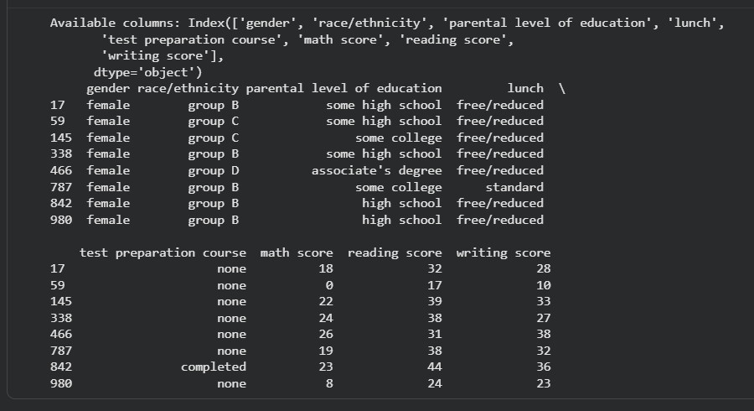
Experiment 6: Remove Outliers using IQR
Title
Removing Outliers using IQR Method
Aim
To remove outliers from a sales dataset using the Interquartile Range (IQR) method.
Algorithm
- Import Pandas.
- Read the sales dataset.
- Calculate Q1 and Q3.
- Calculate the IQR.
- Find the lower and upper limits.
- Remove values outside the limits.
- Display the cleaned dataset.
CODE:
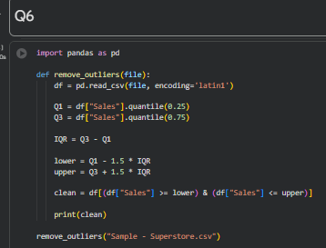
OUTPUT:
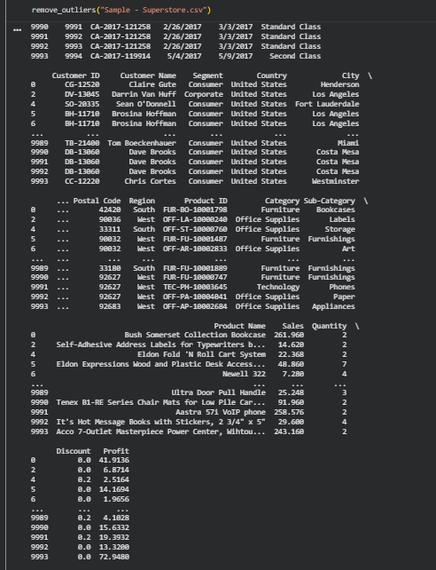
Experiment 7: Histograms and Box Plots Before and After Removing Outliers
Title
Comparison of Data Before and After Removing Outliers
Aim
To visualize the dataset before and after removing outliers using histograms and box plots.
Algorithm
- Import Pandas and Matplotlib.
- Read the dataset.
- Plot histogram and box plot before removing outliers.
- Calculate Q1, Q3, and IQR.
- Remove outliers.
- Plot histogram after removing outliers.
- Plot box plot after removing outliers.
- Compare the results.
CODE:
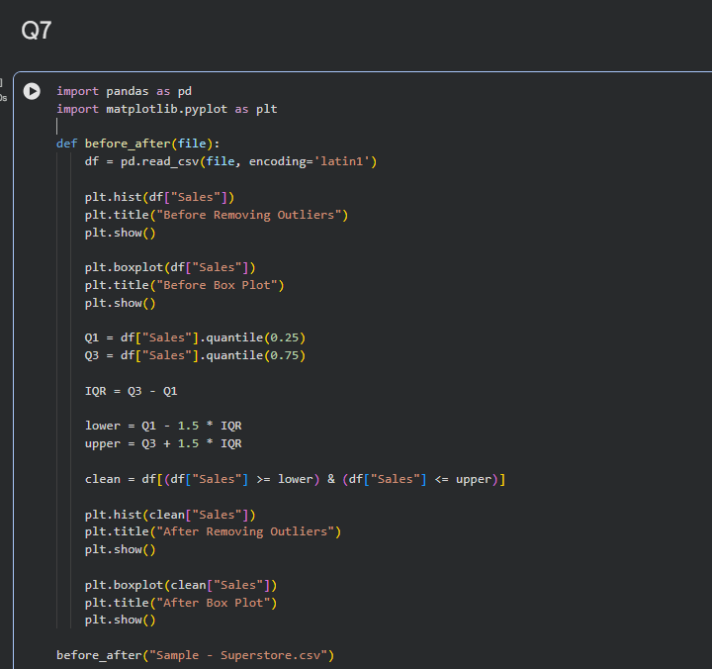

OUTPUT:
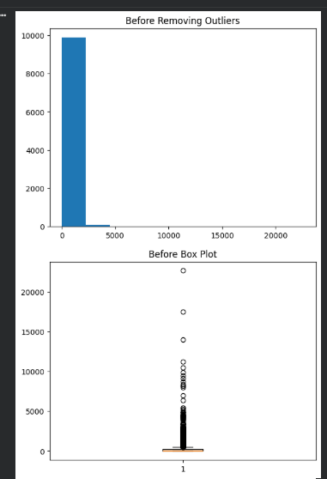
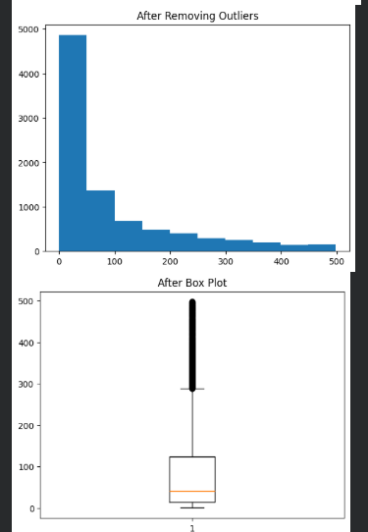
Experiment 8: Exploratory Data Analysis (EDA) on Iris/Titanic Dataset
Aim
To perform Exploratory Data Analysis on the Iris or Titanic dataset by displaying dataset information, finding missing values, computing descriptive statistics, plotting histograms and box plots, detecting and removing outliers, and saving the cleaned dataset.
Algorithm
- Import Pandas and Matplotlib.
- Read the Iris or Titanic dataset.
- Display dataset information using info().
- Find missing values using isnull().sum().
- Display descriptive statistics using describe().
- Plot histograms for numerical columns.
- Plot box plots for numerical columns.
- Detect outliers using the IQR method.
- Remove outliers from the dataset.
- Save the cleaned dataset as a new CSV file.
- End the program.
CODE:
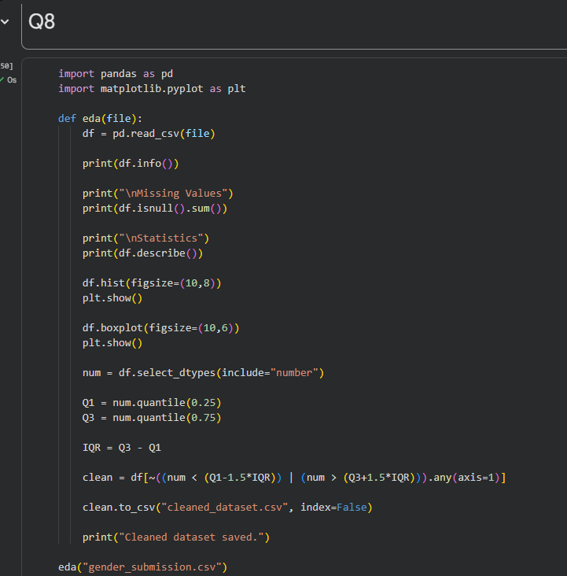
OUTPUT:
